**__________________________________________________________________**



**Submitted to:**

Molana Haq nawaz

**Submitted by:**

Mohammad Areeb Farhan

**Roll no:** BSEF18A007

**Punjab University College of Information Technology,**

**PUCIT (Old Campus),**

**LAHORE**

1. **Gig Account:**

I just created an account on git hub from their official website using my university email address. It is about nine days from now

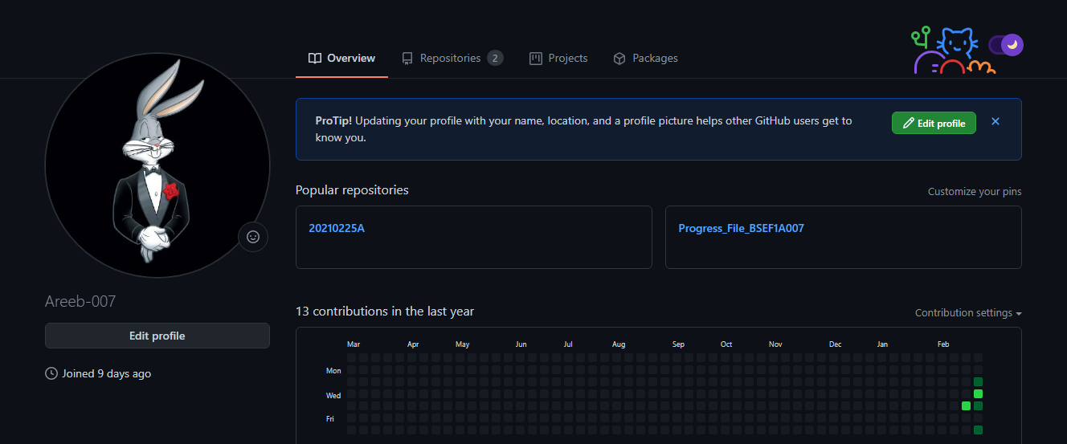

1. **Git Repository**

Then I just created a new Repository by clicking on the “+” button near the profile. Then I named it as “MC_Progress_BSEF18A007”. 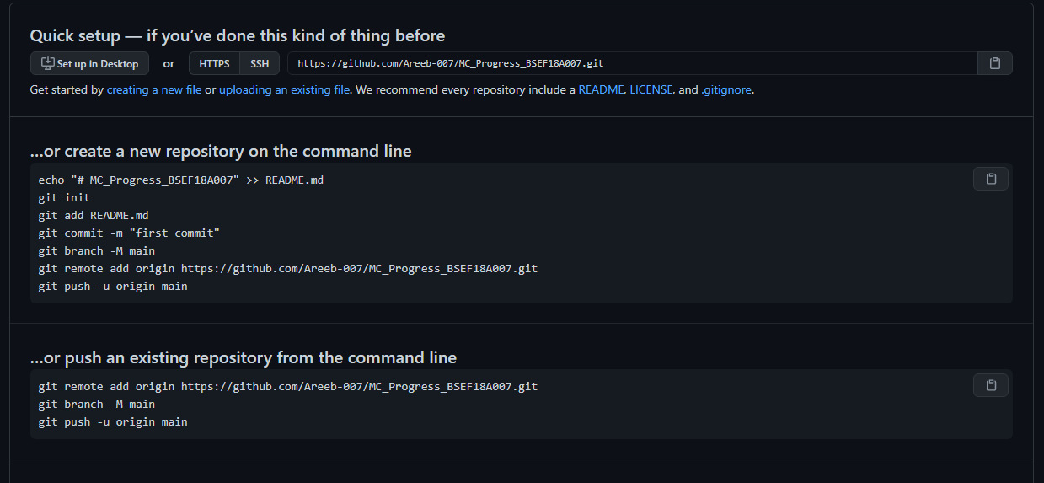

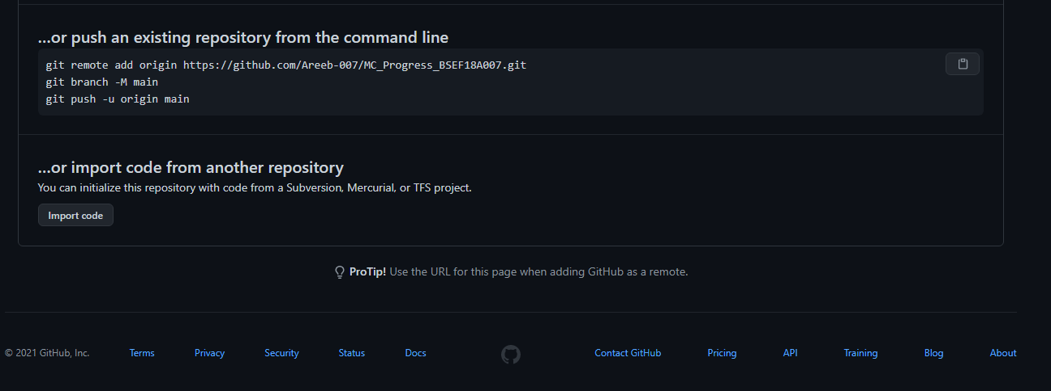

That repository provided me a link <https://github.com/Areeb-007/MC_Progress_BSEF18A007.git>.

1. **Git Clone**

Then in order to convert my local repository into the central repository I am going to use “Git Clone ” command with addition of the previous link which was provided by the git repository.



1. **Git Add**

Then I created an MS Word file named as “Progress_File_BSEF18A007”. 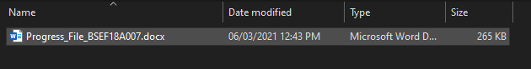

The Purpose of this file is to upload the content we studied so far as per the task was concerned.

Then I ran “git add Progress_File_BSEF18A007.docx” command to upload this file to my local repository.  


1. **Git Commit**

Then to upload the file with the message I used the “git commit -m “Progress File regarding the course” ”to upload that message. 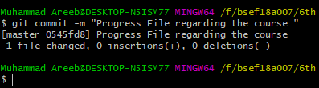

1. **Git Push**

Then to upload the file with that committed message I used “git push ” command

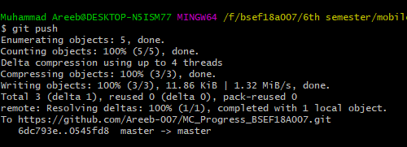

In next picture we can see that the content is uploaded on my central repository as well

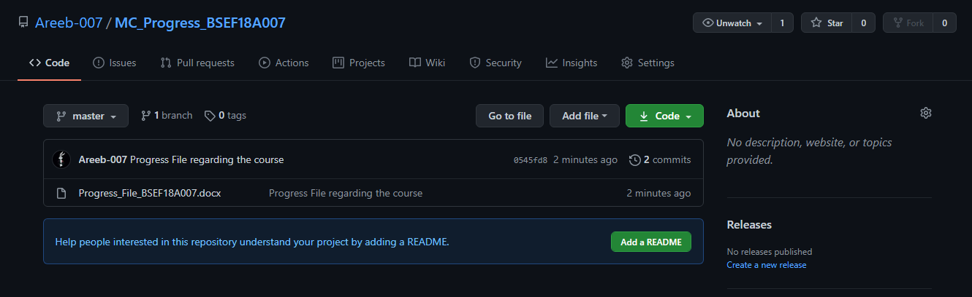

And if we can click on the View Raw button we can download the button as well 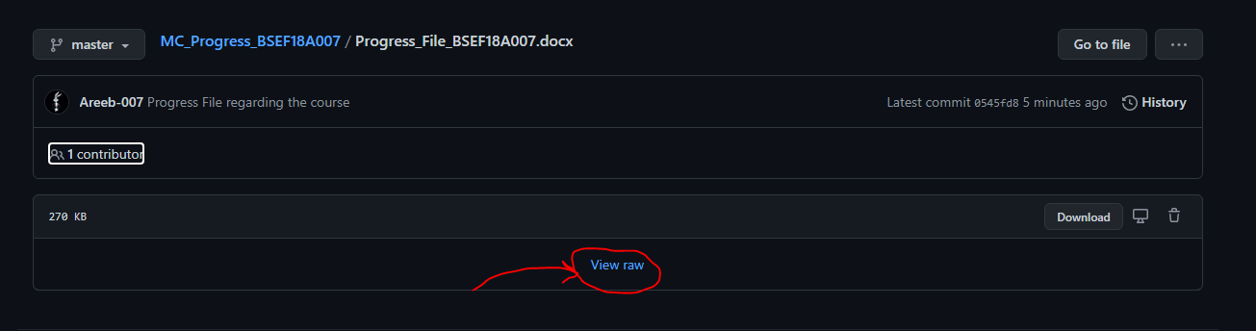

1. **Git pull**

In order to save something from your central repository to your local repository we can use “git pull” command.

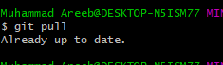

1. **Git Status**

In order to check your status of your repository one can use “git status” command

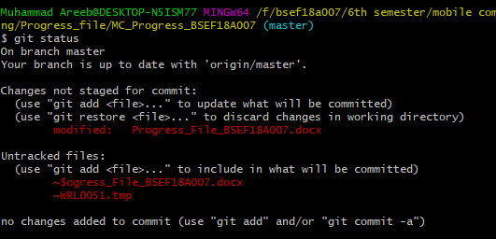

1. **View Content Online**

In order to view your file content online you can visit your git hub repository online on git hub webisite

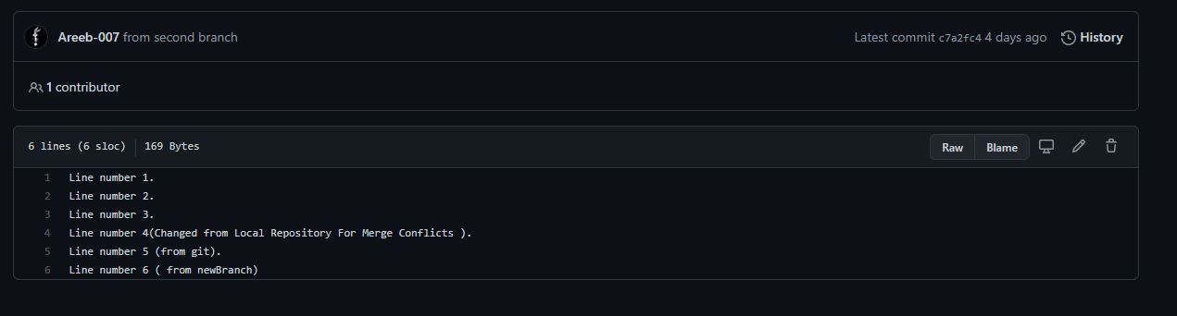

1. **Edit Online**

One can also edit it online from git hub website to update the content of your file.

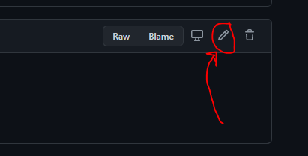

By clicking on the button indicated we are able to edit the file online.

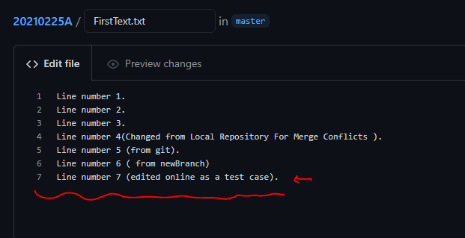

Now to save the content one just updated we click on the button below labeld as “Commit Changes”

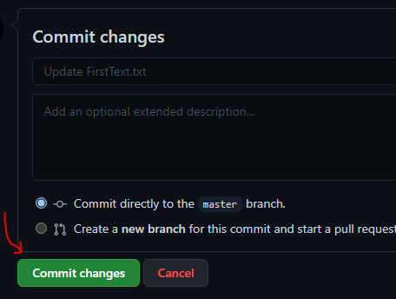

1. **Git pull**

We just updated our central repository online from the website but our local repository is still as it was before update. In order to resolve that issue one can just use command “git pull”.

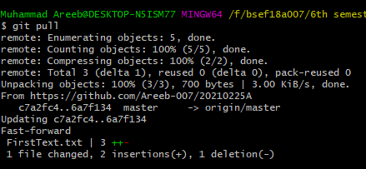

1. **Merge Conflicts**

Merge Coflicts occur when we try to change same line from local and central repository at the same time 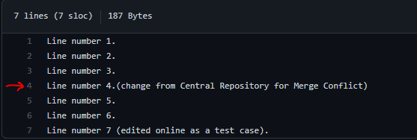Above are some changes from central repository.

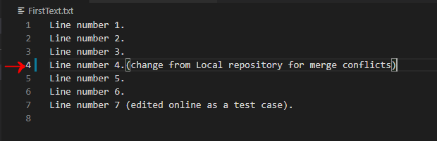

Above are some changes from local repository. Now when ever you try to add or push the file it will produce an error. 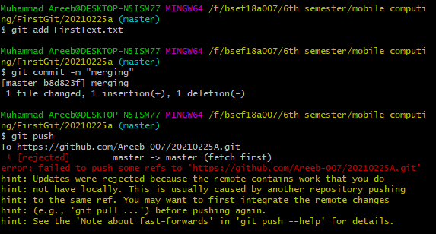

To solve this issue we have to choose one change either from local repository or central repository. Now when you run the command git pull we can see some following things. 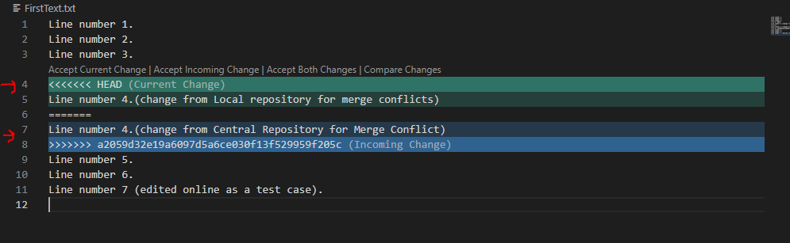

So we have to select one change from those. When we select one of those and then retry to add ,commit and push we get this.

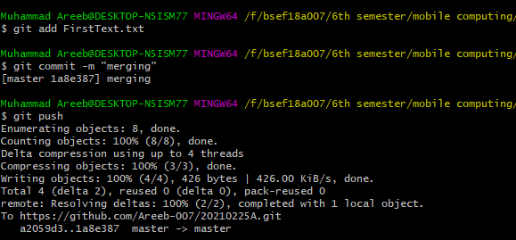

From Local Repository:

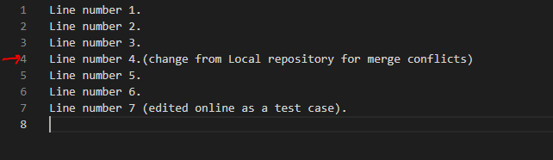

From Central Repository:  
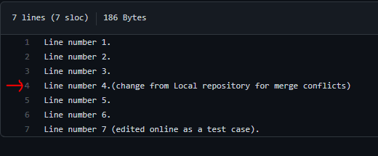

1. **Git Log**

In order to see the commit details we can use “git log” command. 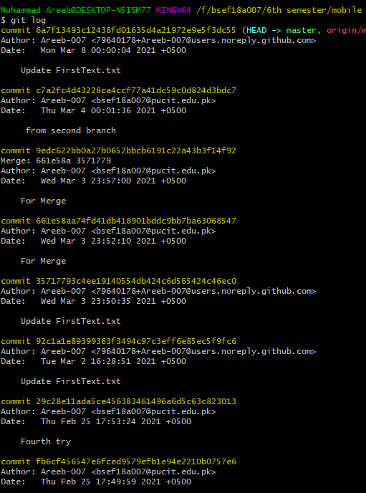

1. **Branching**

Branching is a very helpful and important feature. It is used to perform working in a parallel mode.

* **To Create a new Branch**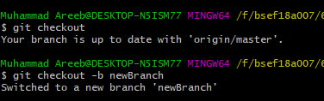
* Now if we edit the file it will be edited in this branch but whenever we shift to the other branch there will be nothing changed, which will be seen in the following pictures:

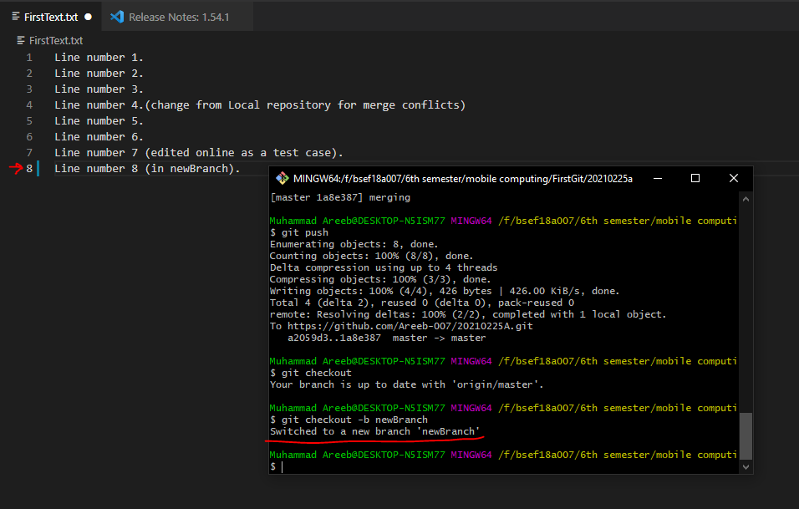

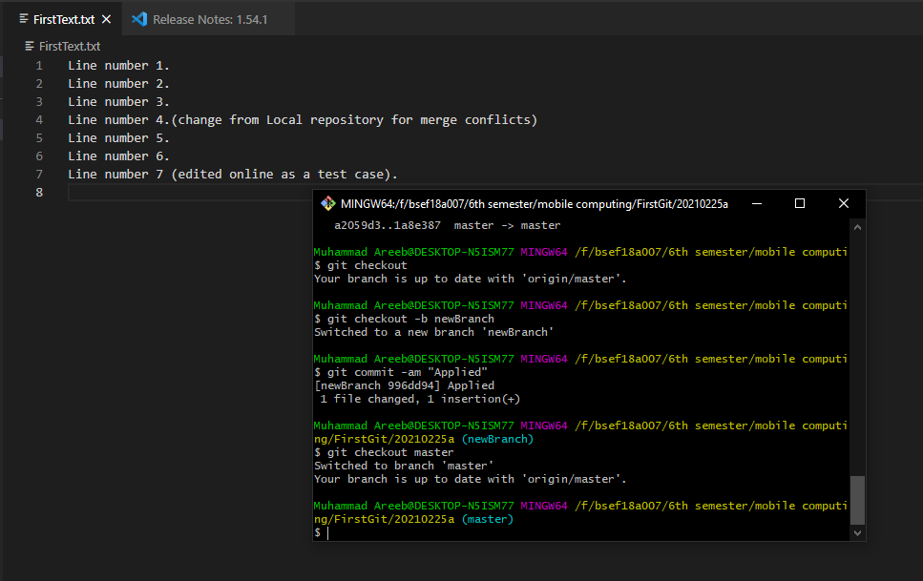

Now in order to merge those branches we can use “git merge branchname” command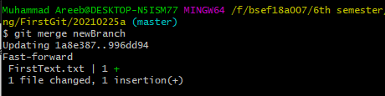

Content in the file are as follows now  
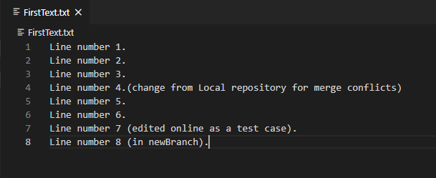

**Android Project**

1. **First Attempt**

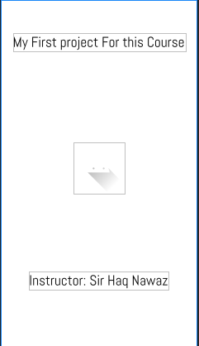

1. **Second Attempt**

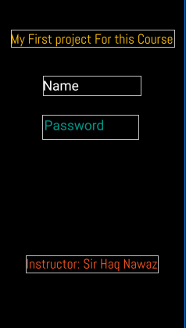

1. **Third Attempt**

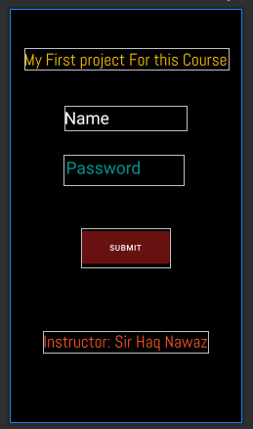

**Views and Layouts**

There are multiple views and view groups for example the button view, text view, list view etc. All these views are grouped in the Layout. There are multiple layouts available in the android Like Linear layout, relative layout, grid layout etc. But every layout must need to be the part of a root layout. All other things are the child of the root layout. So here is an example of how to do it.

At First I added another layout as “linear_layout” (naming conventions must be followed)

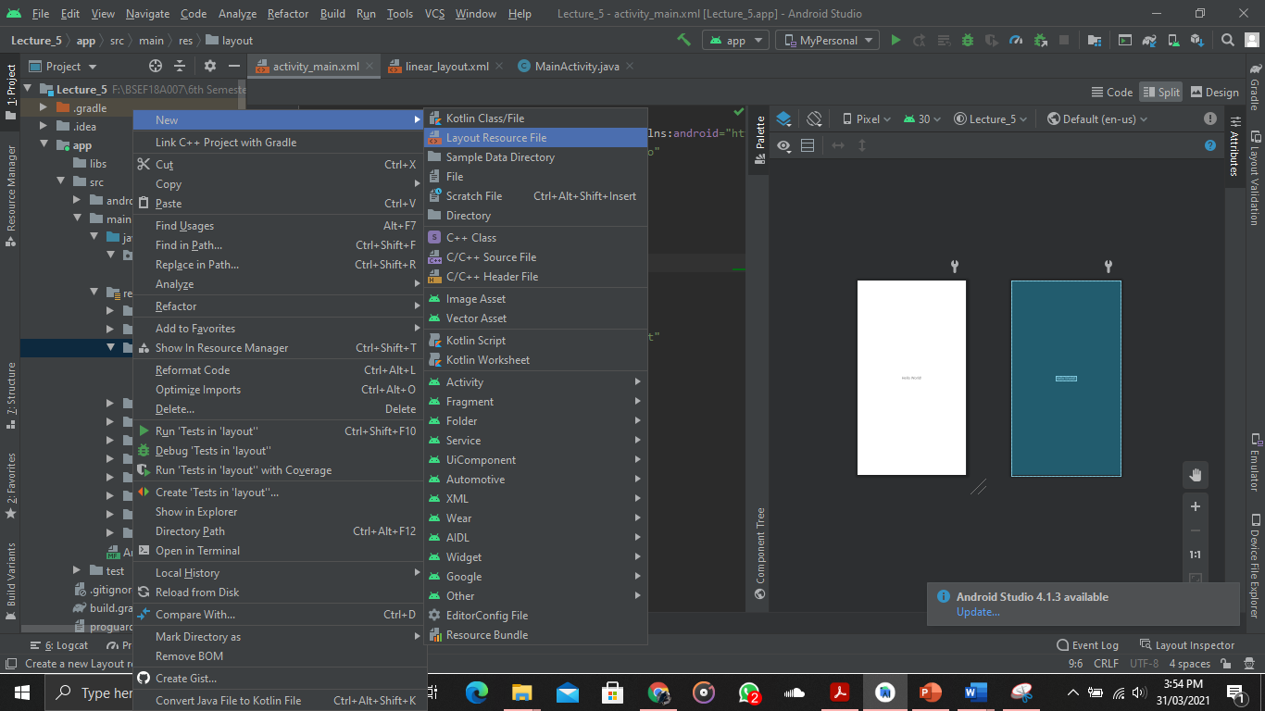

That is how we are going to add a new layout in our project. 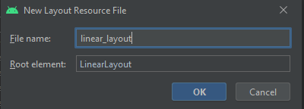

And then we can see that the layout is there 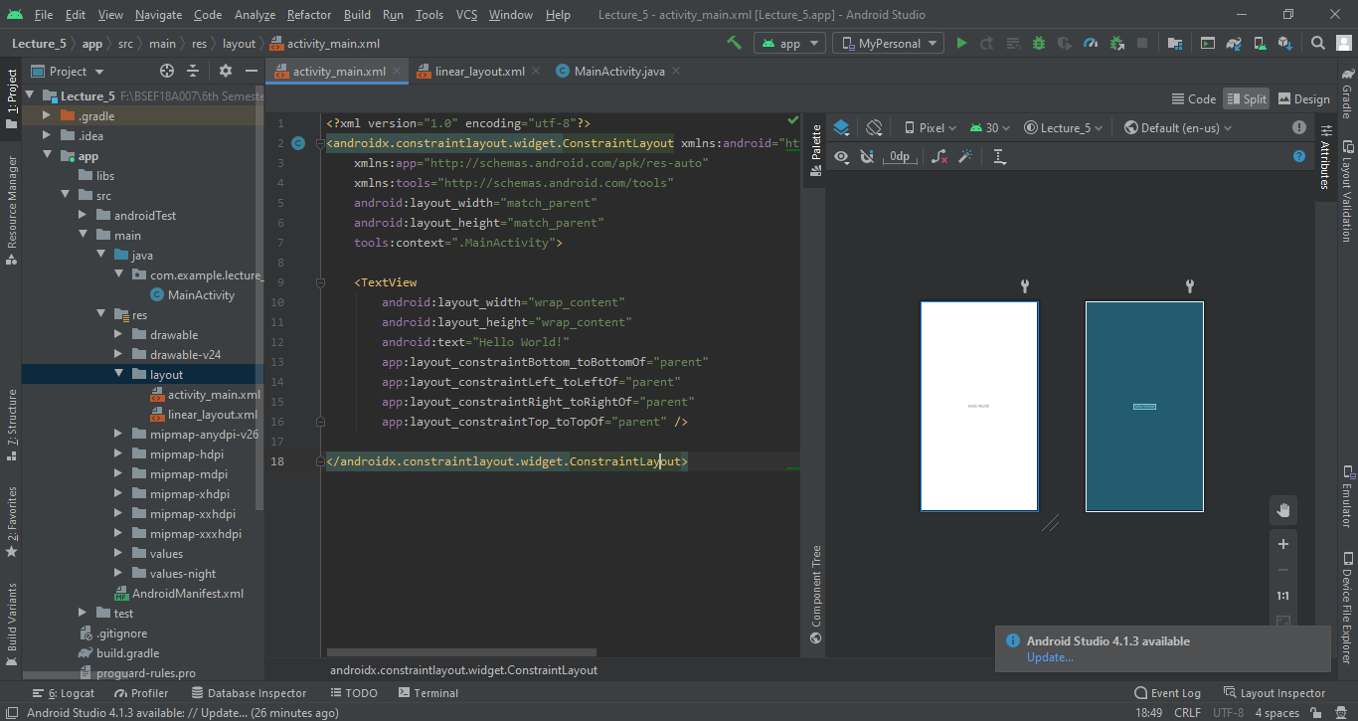

As you can see I am using split mode it is very helpful in setting costraints layouts and items with in it.

So if I add Text view and a button It will look like this

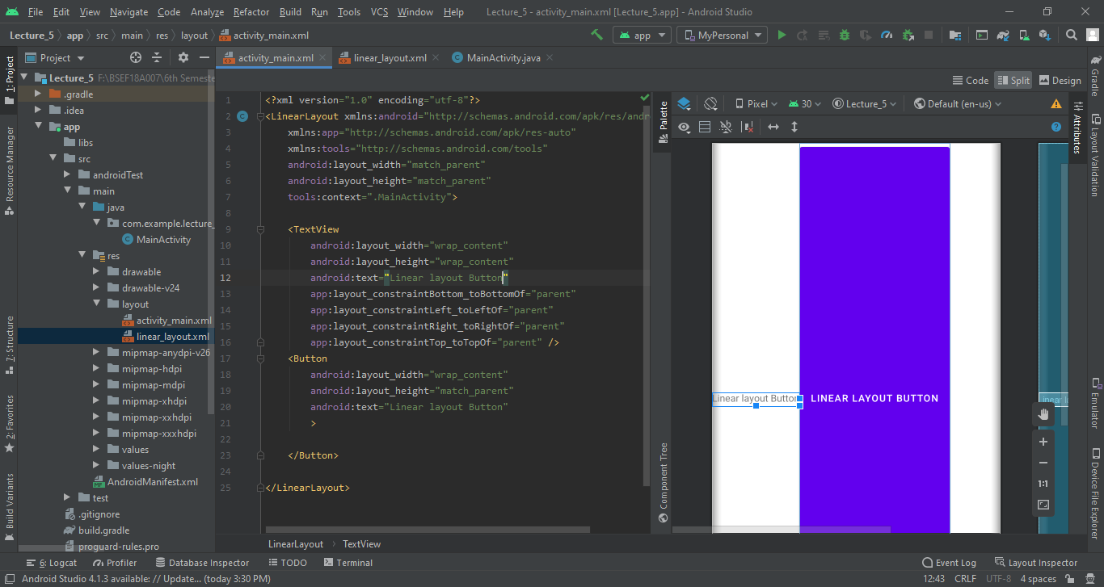

Now if I add the property of orientation vertically it will look like this. 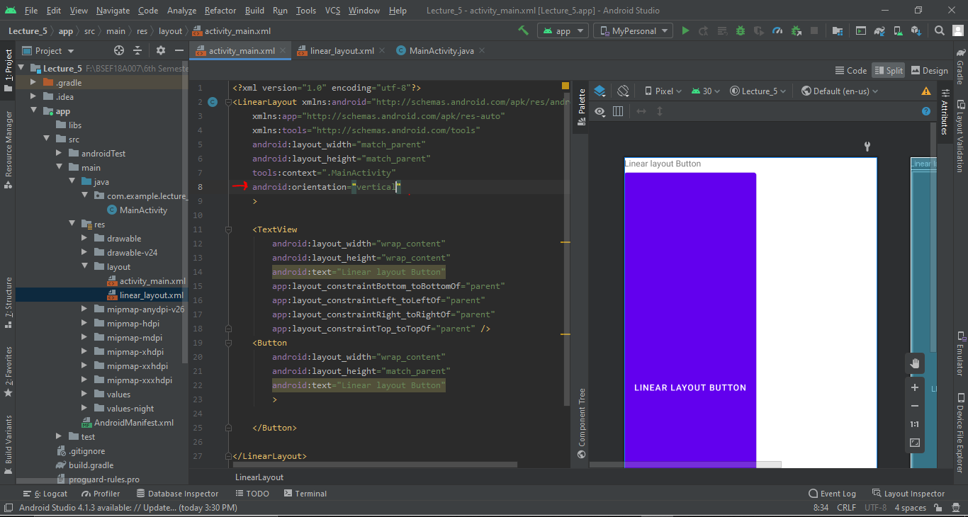

Now I am going to add some widgets in our pervious layout (Constraint Layout) and see what happens if we manage them.

**Animations**

Now we will see that how you can apply eye catching animations on the elements in the android studio in your app. For this purpose we will go through a slightly differnet approach. One approach is to animate and object in main main activity by simply using the property of object.animate and then the animation properties like rotate or alpha property for the blur effect.

But here we will go through another property of creating an Anim resource file and then creating animations.xml files for achieveing the same purpose. This methods helps us in lots of ways. Because there are some properties which are available easily through this method but not through the previous direct method.

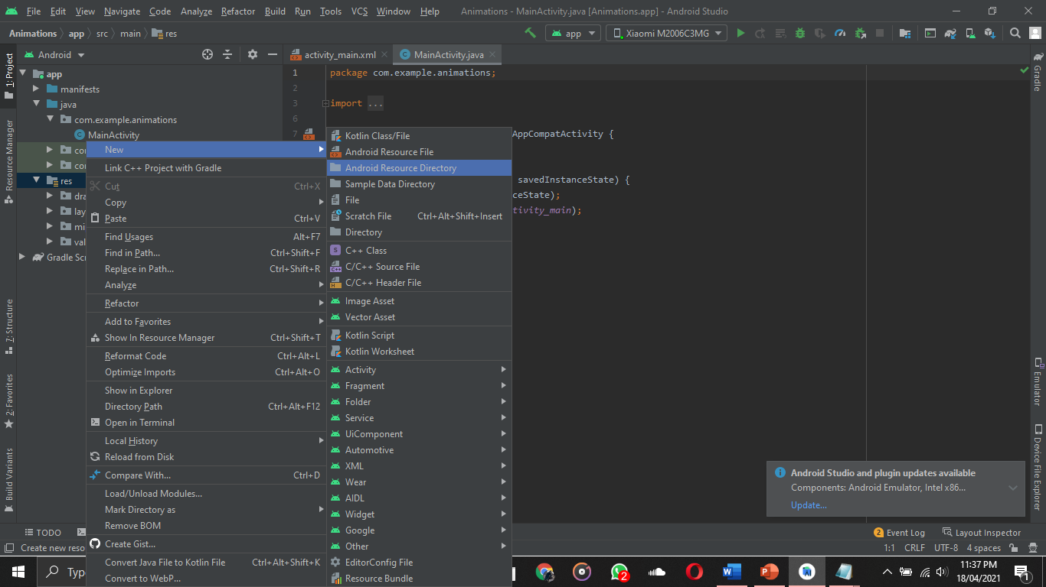

Here we will select the anim values for our purpose.

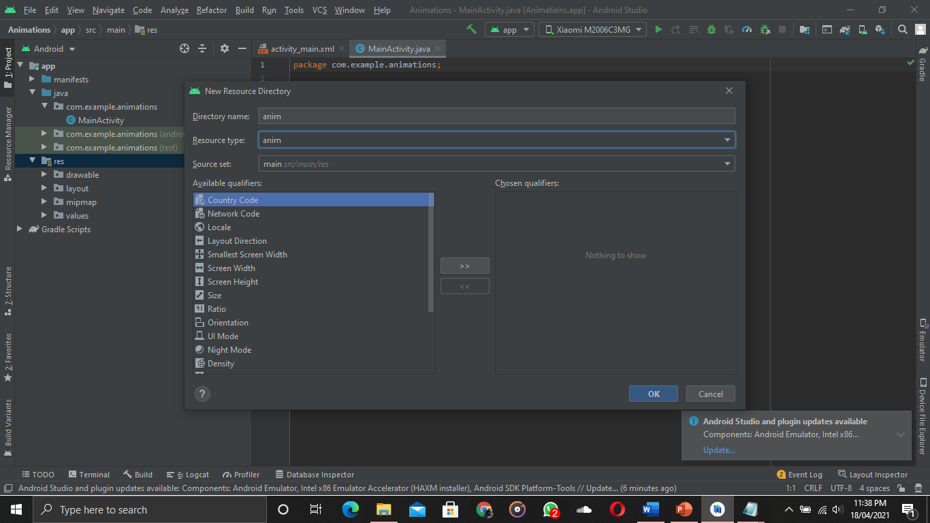

Then we will add an anim resoursce file

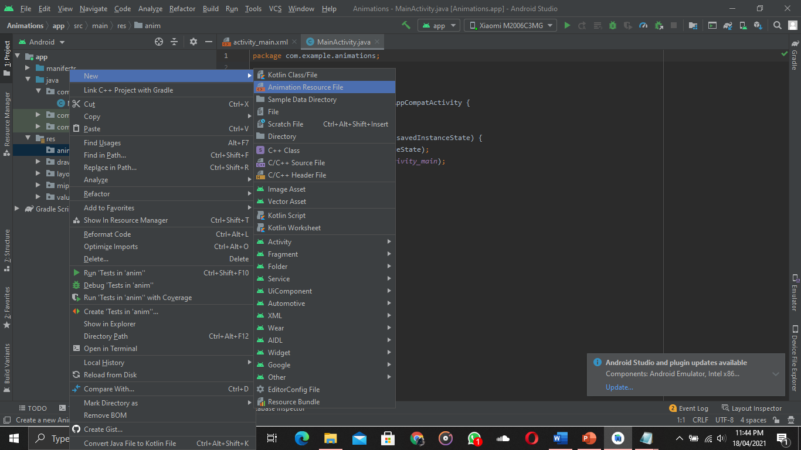

-----------------------------------------------------------------------------------------------------------------------------------------

**Database Manipulation**

In order to save some thing on the database we have to create a Database on our android device so that we can use the functionality of the databse. The database we are going to use is the SQLite Database which is provided by the Android studio. So in order to create the database we must define a database handler class. 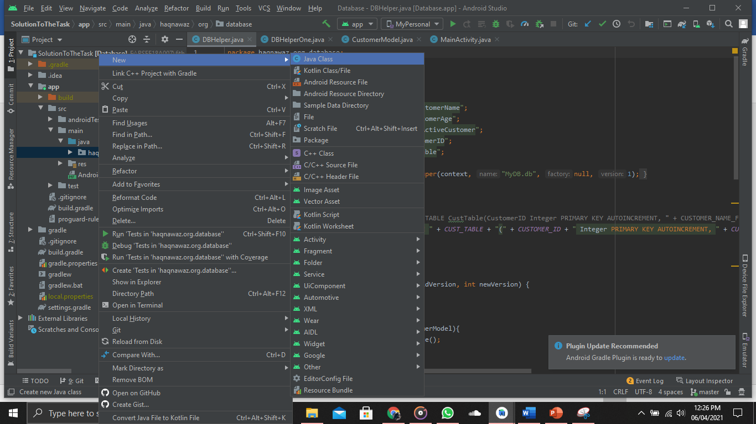

When we click on that it will ask us for the Class Name We have to name it as “DBhelper” which is playing the role as the DB handler Class.

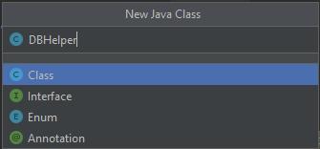

This will create a java file where we will implement our Database handling code. We will create a class with the name of DBHelper and will iherit with the SqliteOpenhelper Class.This will help us to use the sqlite functions like oncreate and onupdate which are used for some other purposes.   
In the On create method we will write the Query to create a table we want to use.

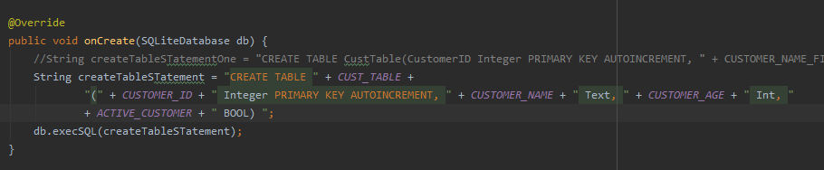

Then we will create an onther java class just like the same way we did it preciously to define a customer model which we will add in the database table customer. Also we have declared some static variable for name of table and columns of the table (which are the attributes of the class we are going to implement).

Java Class with desired attribute and their getter and setter as well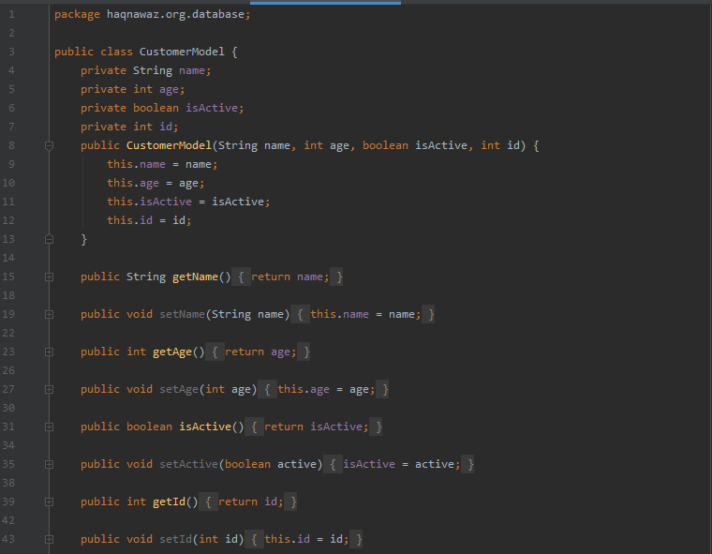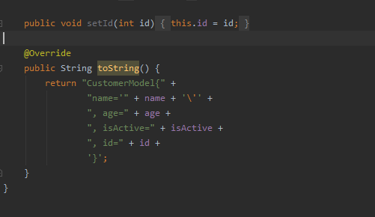

Now the Add Customer method in the DB Helper so that the it can add the customers In the Database

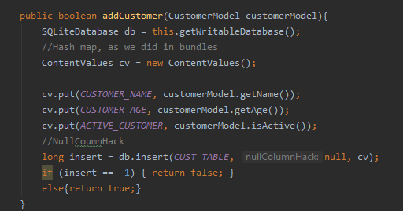

Now the get all customer method so that we can view it on the App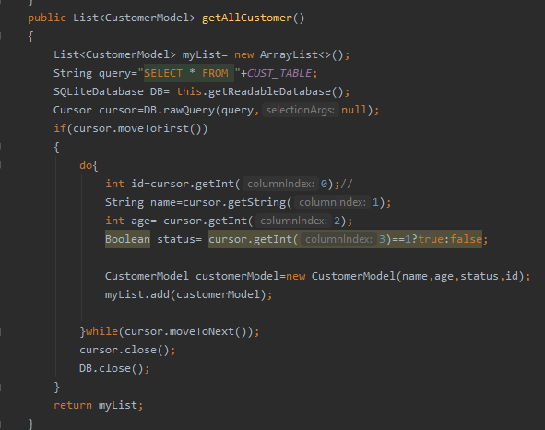

Now a delete method so that it can delete an item from the database .

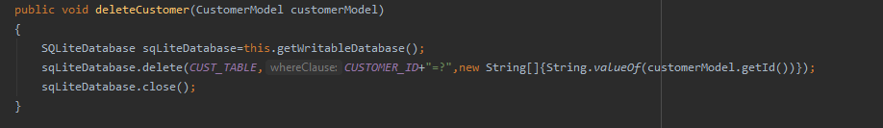

Though the above method can also be implemented using the query method as well.

Below we can see the customer Table in the Database using DB Browser Sql Lite

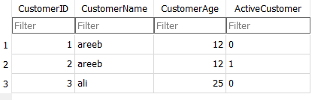

In order to use this we have to generate the database file first which we can do in the followig method:

Go the View->Tools Window->Device Explorer and then click

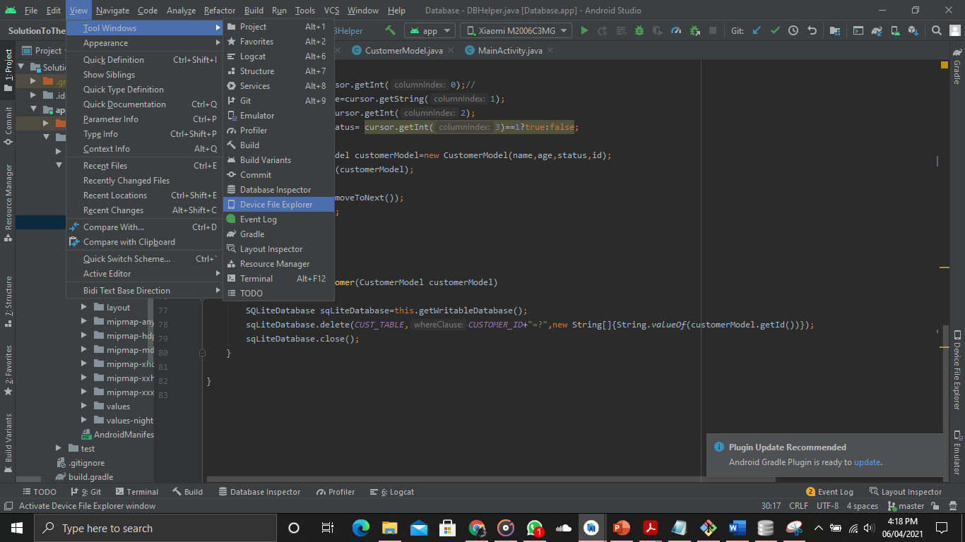

Then data-> data-> your package name -> databases -> your database

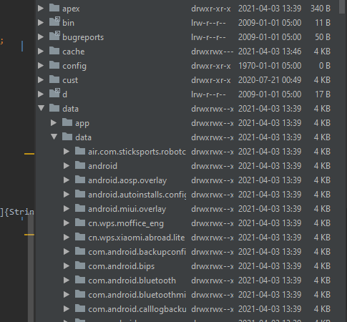

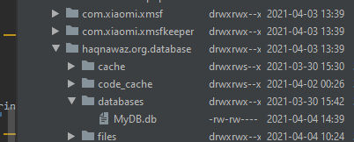

The right click on the database and save as name.db on any desired location you want.

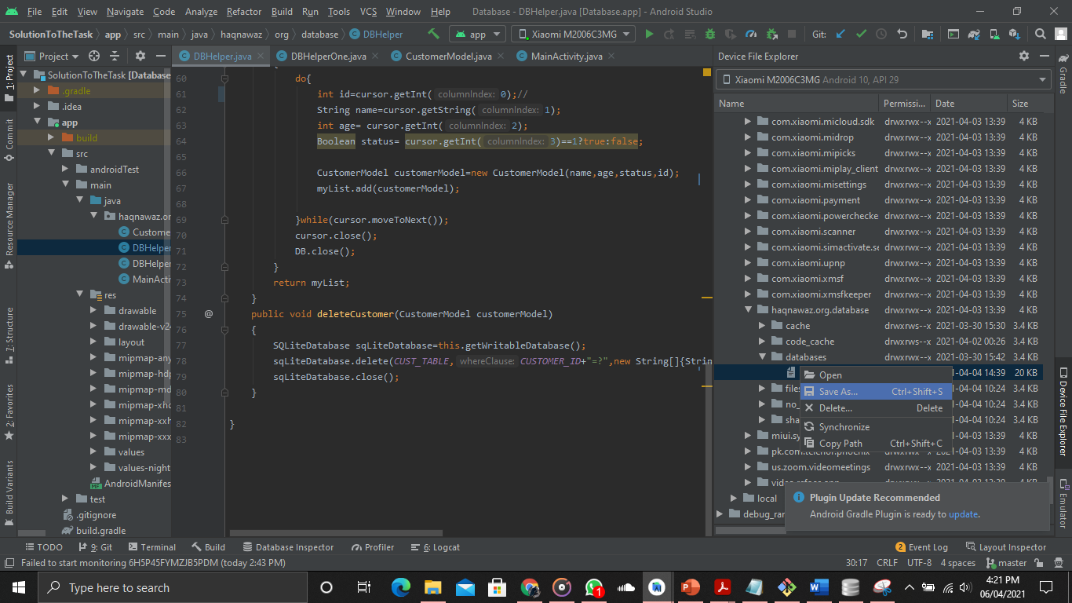

Now open you DB Browser and click open database , browse your db file and then click on it

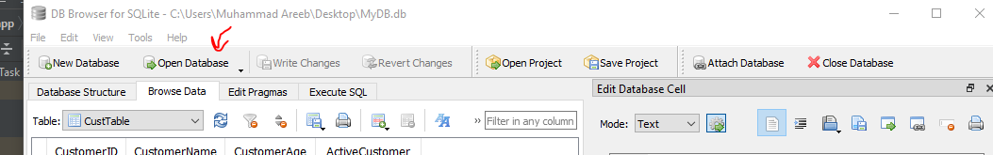

It will view it on the db browser application

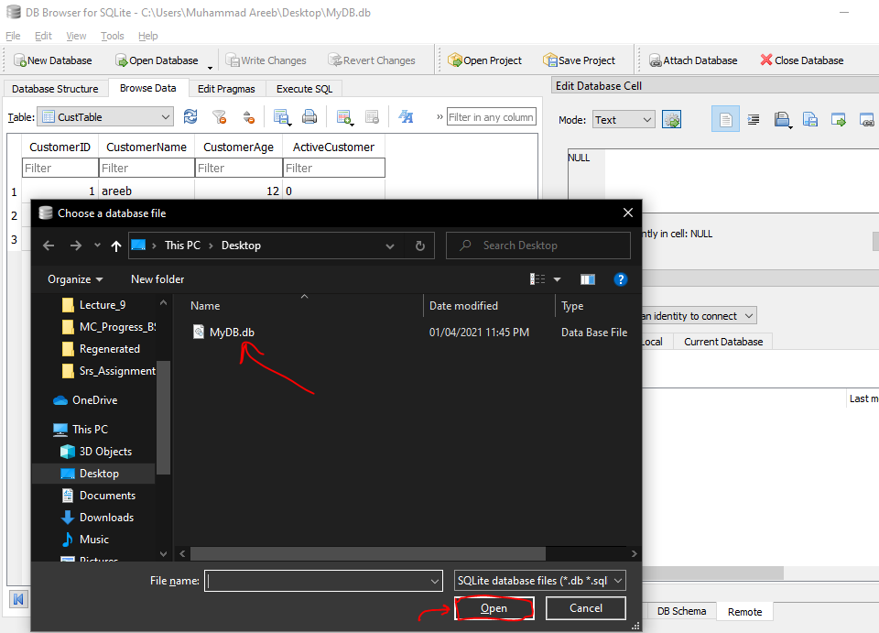

Now here comes Main activity code for the database lecture

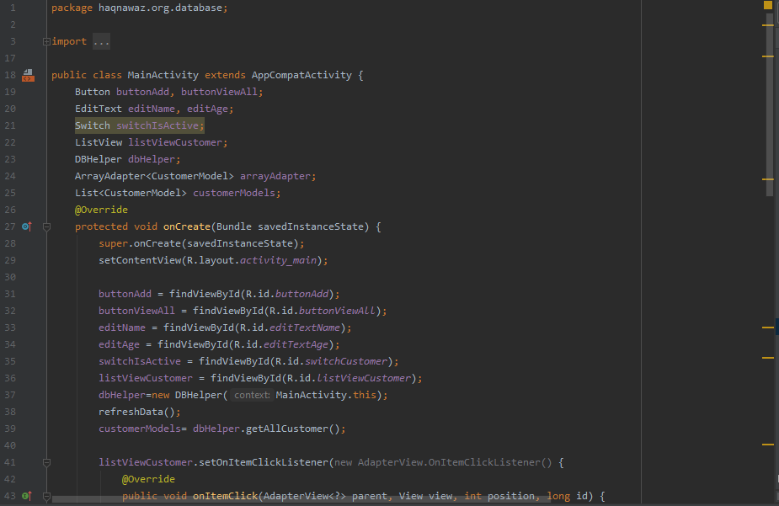

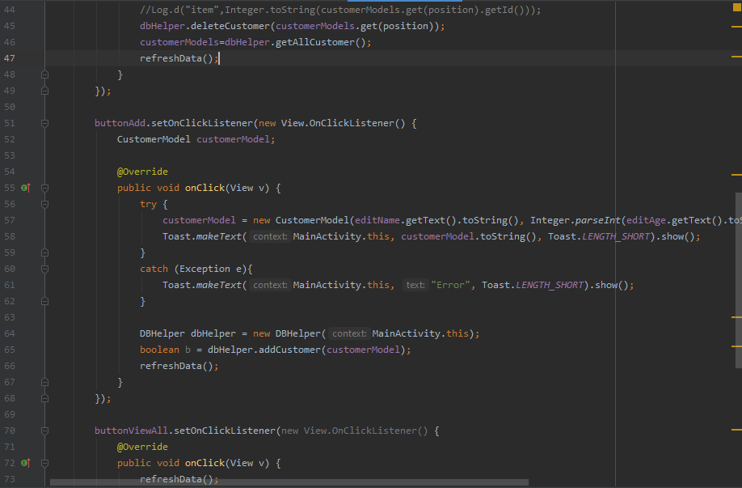

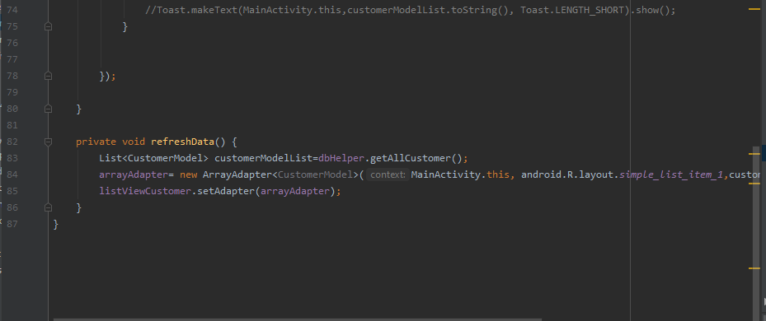

**Navigation Drawer**

For this purpose we have to create two things. First is the header and second is the navigation panel and we will see both of them step by step.

Now in order to add some icons we can use the porperty as vector asset by right clicking on the drawable and the go to the new and then go to the vector asset for the icon. Some Icons are available in the android studio other we can also add then by downloading it from the internet.

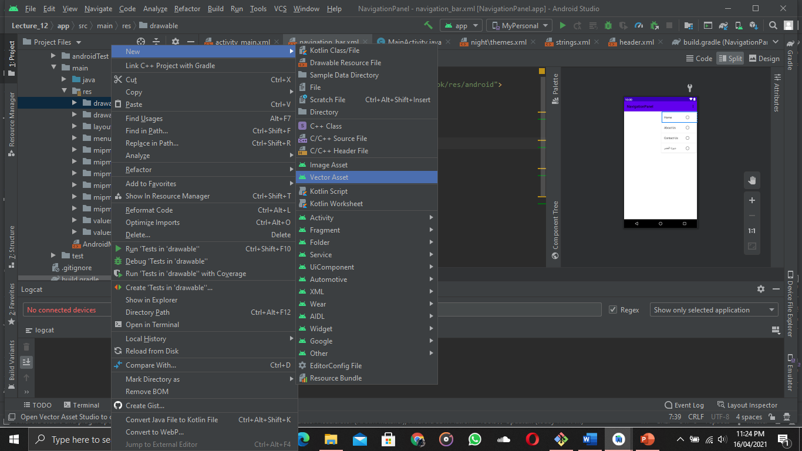

By clicking on the vectore asset a dialogue box will open

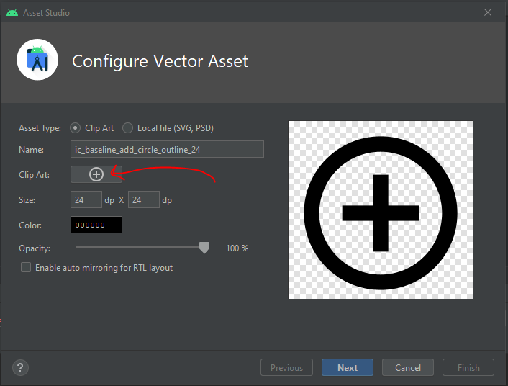

And by clicking on the icon you can add an icon at your choice as desctibed below

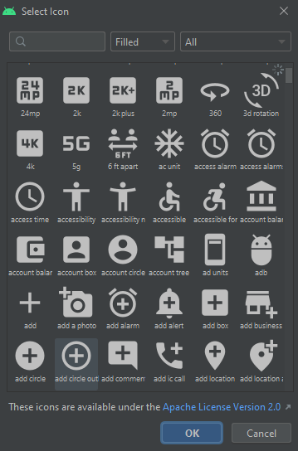

This will show up and by searching you can use your desired icon provided by the Android Studio

Now in order to not to show your action bar you can add a property of “windowActionbar” false in the res/values/themes/themes.xml

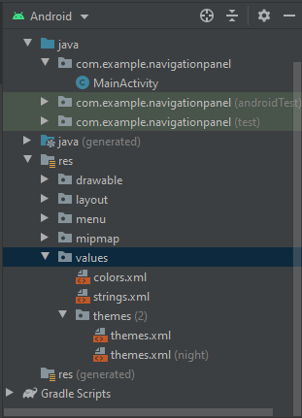

Then add the attribute 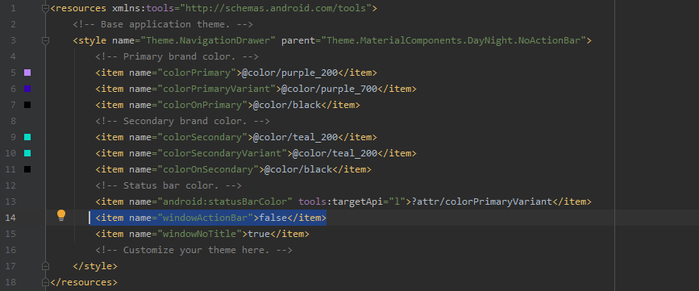

This will help us to show our toolbar at the top where the windows Action bar was used to be

Now in the resources folder we are going to create a Menu Directory and add the menu using linear layout. Then we will add the menu items in the menu which will be displayed when we use the app

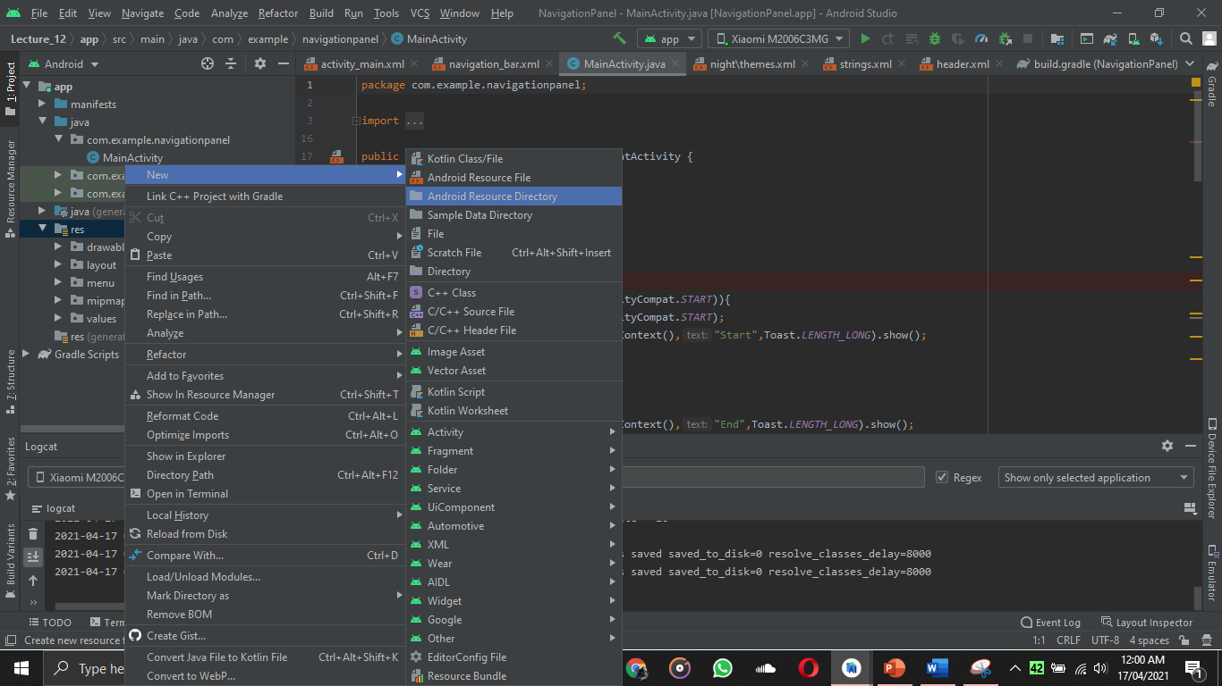

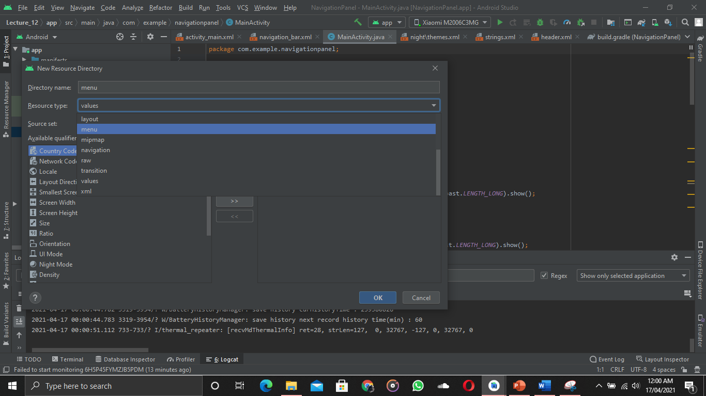

Then by right clicking on the menu directory we are going to add the menu resource file as well

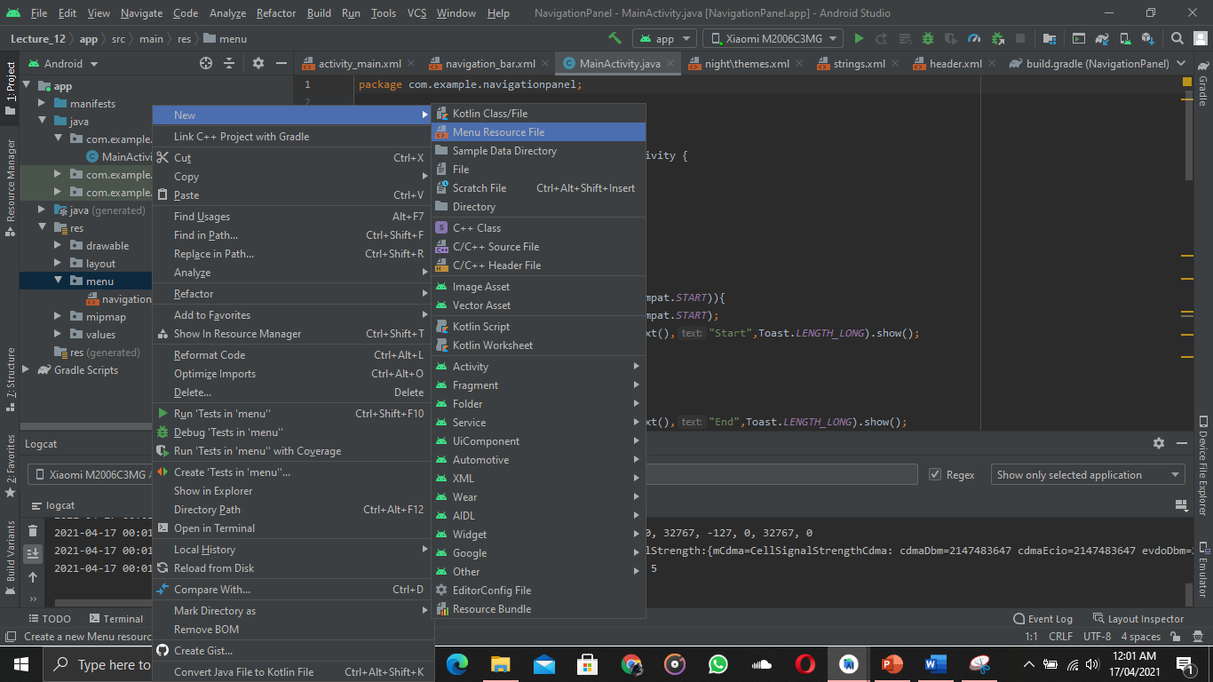

In the menu resource file I have added some menu items and have set their icons from the vector asset method like I showed before

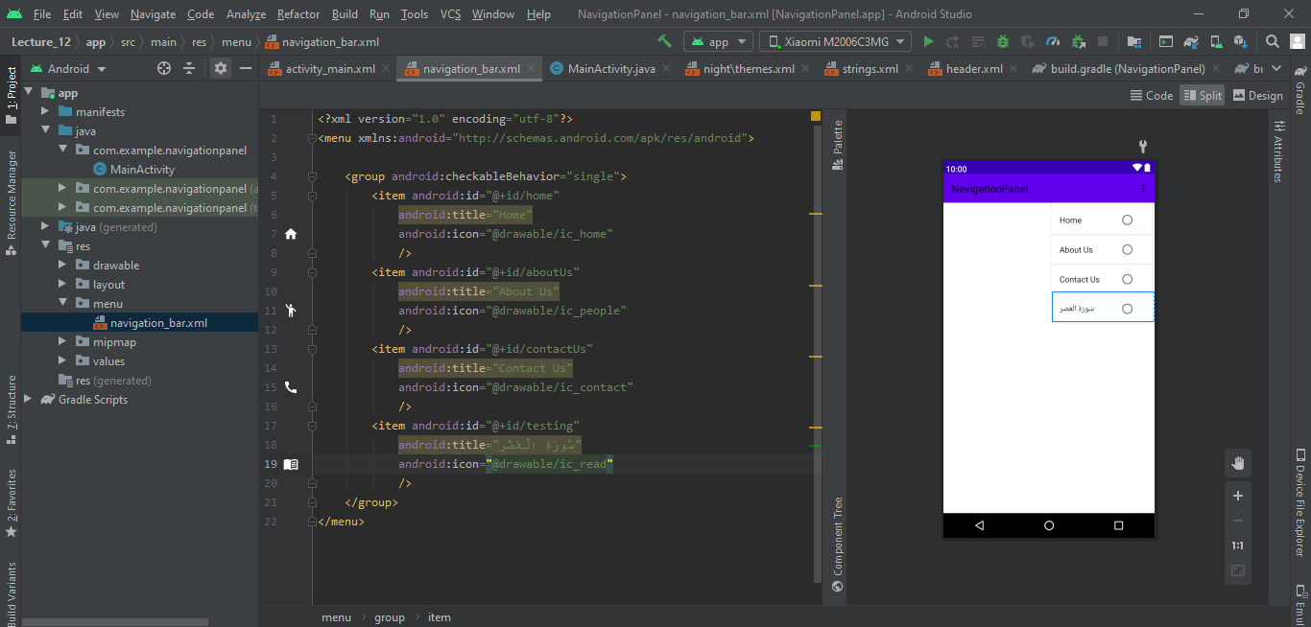

Now I have created a header file in the res/layout so that it will be displayed as header in the navigation drawer

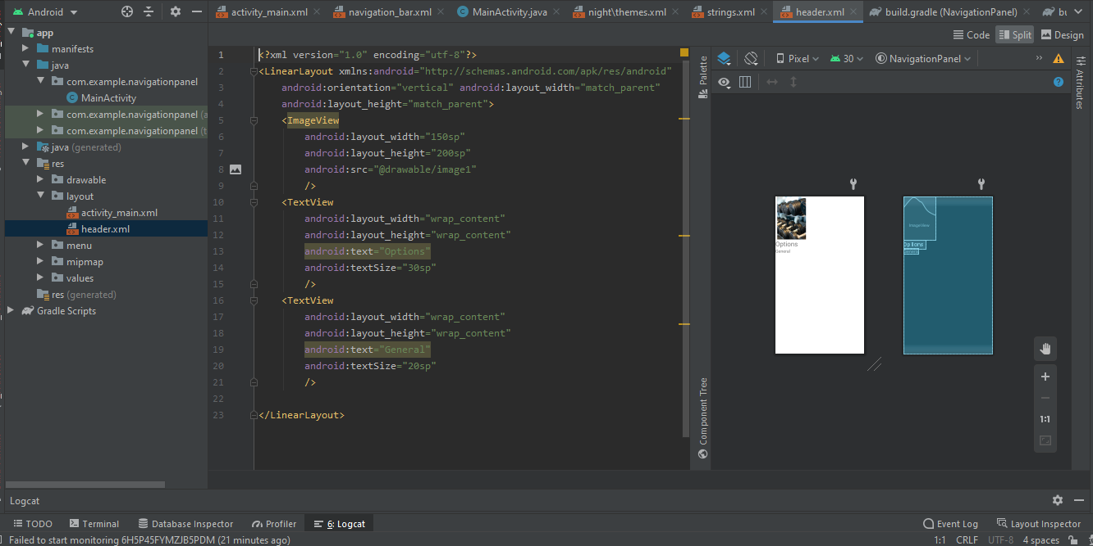

Now as I am done with the header and menu thing now I will add them on my activity_ main layout

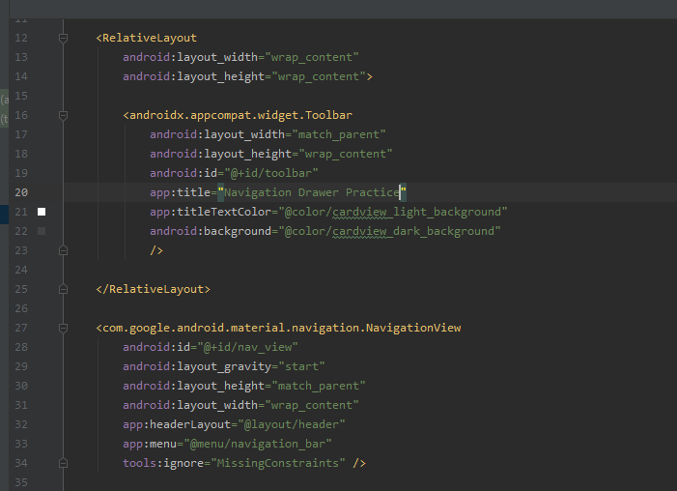

Now in order to hook the toolbar, toggle buttons and other elements we will do this  
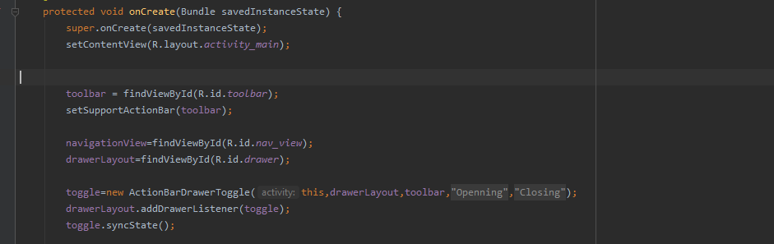

Now if I want to add some functionality on clicking the menu items then I will do this as described below

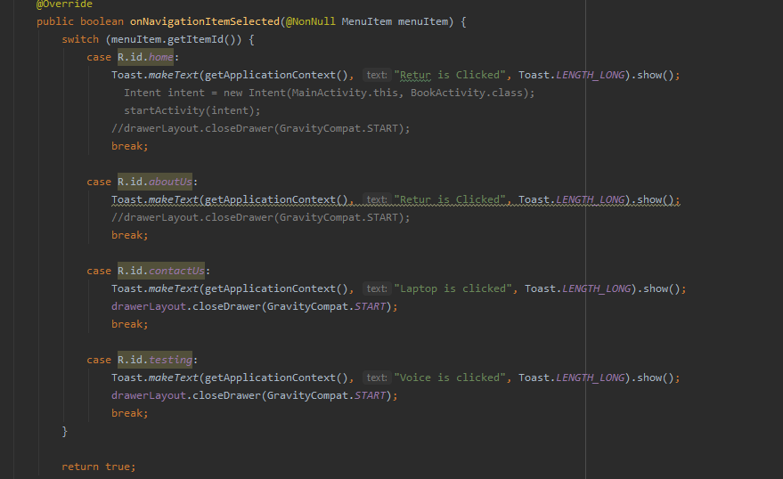

The output will be

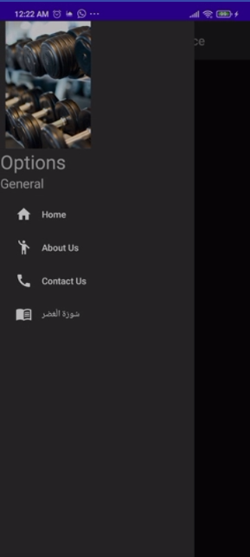

**Recycler View**

Now we are about to start recycler View. So what is this Recycler View. This is a very simple and helpful tool to use against list items. Recycler View has two major benefits over list view:

* We can create a layout as an item to be displayed as a list while in list view we were only displaying the string on list
* The second is the most beneficial advantage which is that the recycler only load that items which can be displayed on the screen while list item first loads up all the list item before displaying the items which in case of very long list is going to cost a lot of time.

So lets get started. First we need to create an android empty project and then we will add a recycler view on the activity_main_xml. 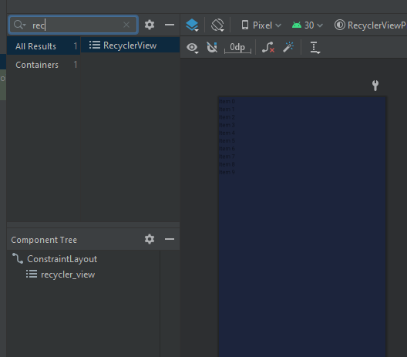

So basically we need are two important things first one is the View Group that is used to hold or manage the views created. The second thing is the Adaptor class which will help us in inflating the views. We will also have to create a view which will be shown to the user as layout in the form of a list. 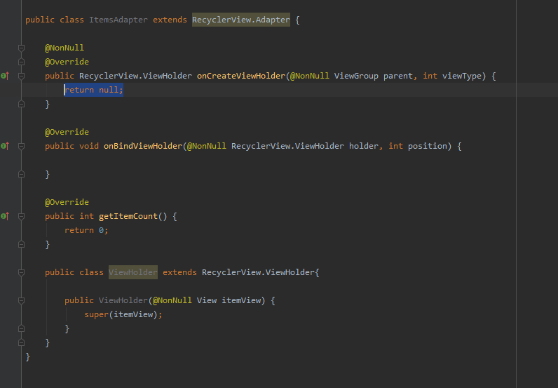

So here what I have done is simply that I have created a class named as ItemsAdapter and have extend that with RecyclerView.Adapter and then I have created an other class within this class named as RecyclerView.ViewHolder and has implemented the necessary constructors.

Now as we know we are going to need a layout for out items which we will present in the recycler view as a view. And that view will be managed by the view group. So here I have created a layout to display a car’s infromation.

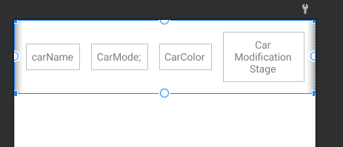

So now we are going to write some code in the adapater class so that it starts working. So in order to populate the recycler we are going to create a class which can store necessary information of our class.

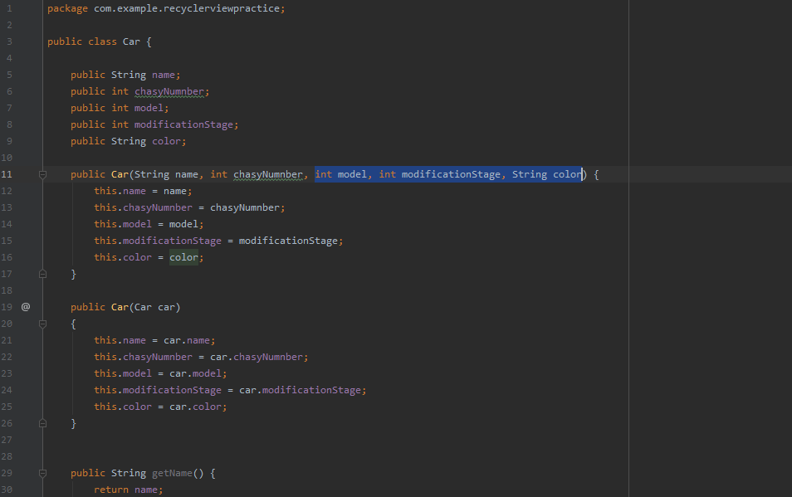

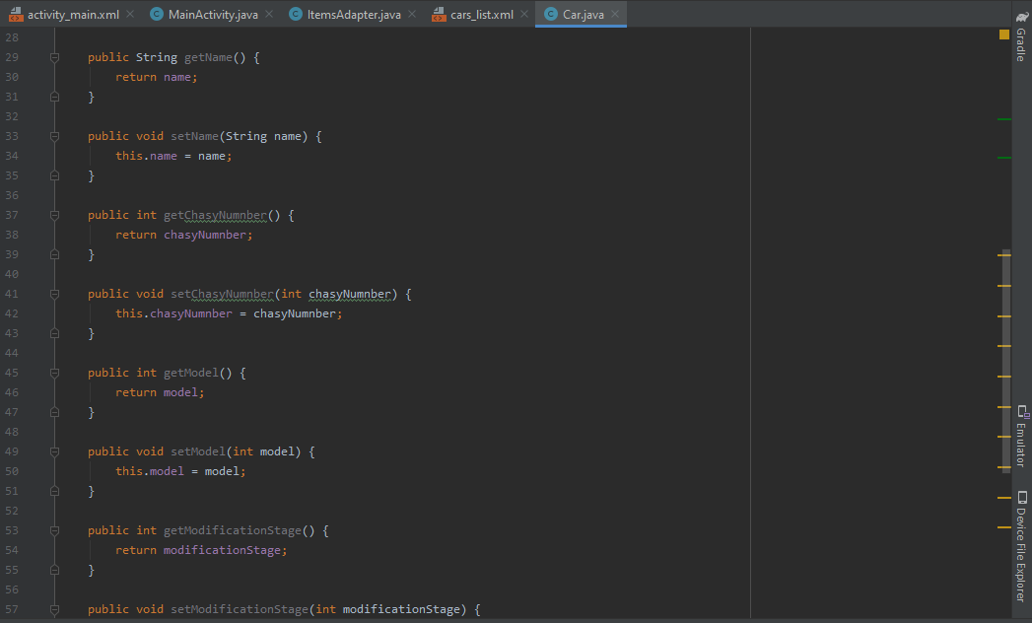

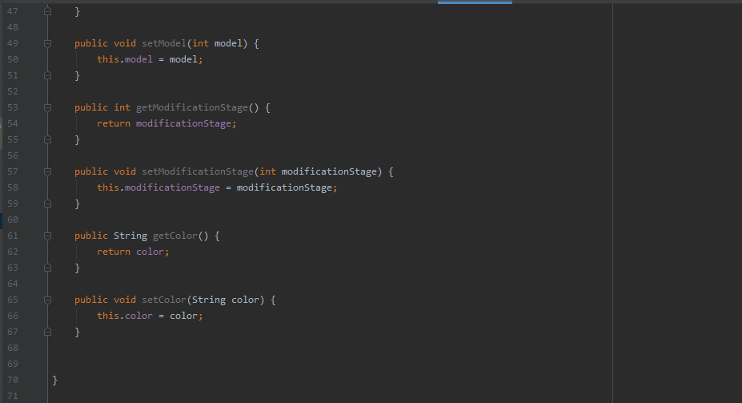

Now we are going to poulate our Item Adapater class so that It can be displayed on the screen. 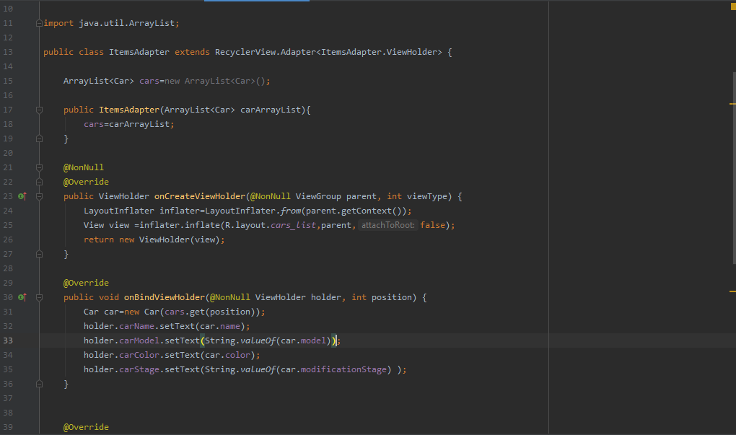

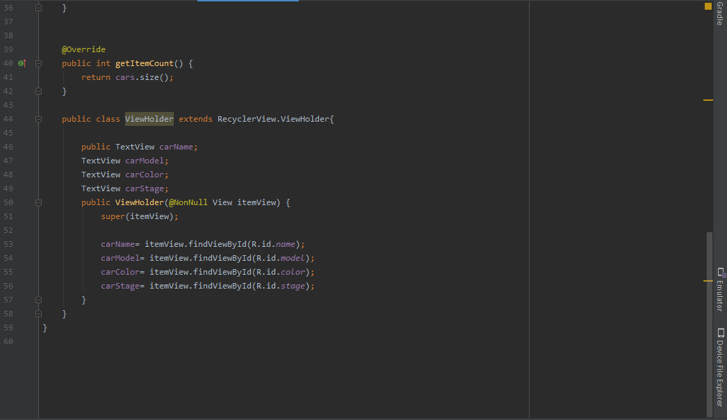

Now we will write some code in the main activity to invoke these methode and will provide them with a dummy data.

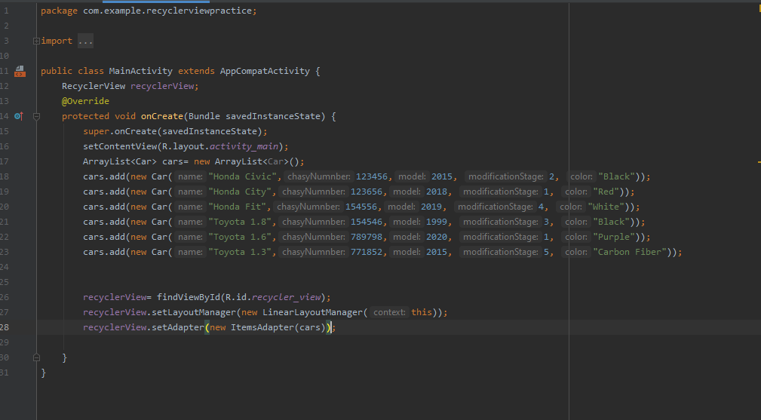

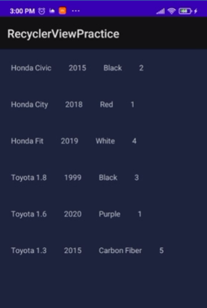

**Dialouge Boxes**

So till now to show a message we have used the functionality of Toast to interact with the user. Now we will discuss another method of interacting a message or a taking some input input from the user. Andoroid Studio provide us with the functionality of the AlertBoxes and Timmer/Date Boxes. Here we are going to implement the Alert Boxes.

Here we will implement 4 types of the dialouge boxes.

* First will be simple dialogue box in which we will display a simple message
* Second we will display the dialogue box with some data in a list
* Third we will display the dialogue box with multi choice selection feature and will display the selected item
* Fouth we will display our own customized layout in the dialogue box

So lets get started.

So at the start I have created 4 buttons for the 4 types of the dialouge boxes

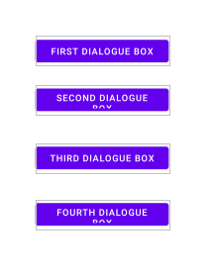

And have implemented a method to be shown when the button will be clicked.

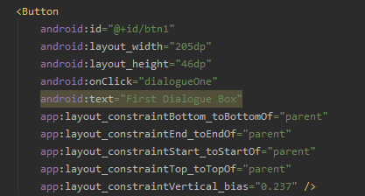

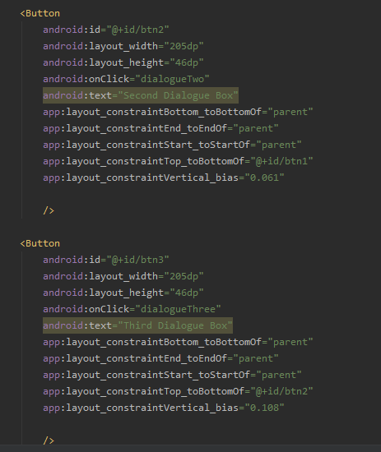

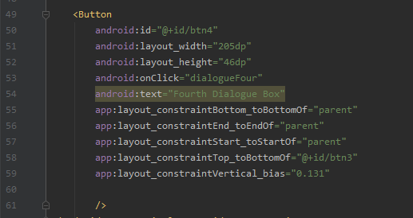

Now we will write some code for the funcationality of the dialogue boxes

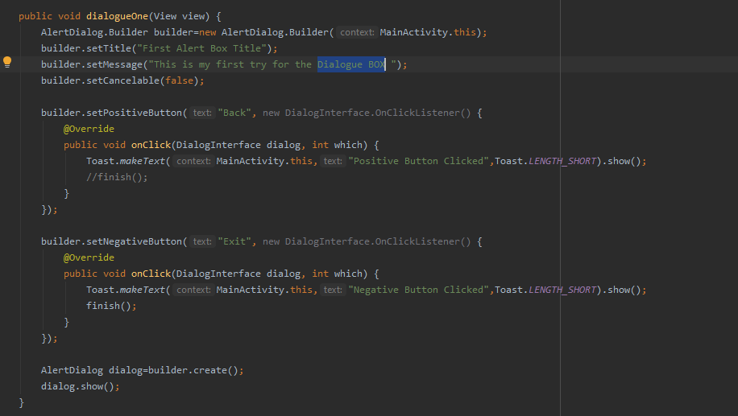

On the first button click we it will simply show a dialougue box with a simple message and title. Also there are two buttons one is negative and the other is positive this can play the role of the “back” and “exit” button role on the dialogue box.

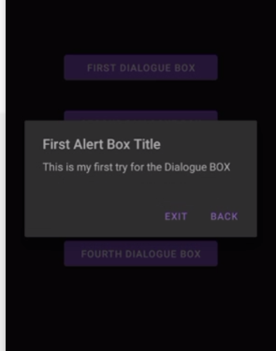

Now the second dialogue box

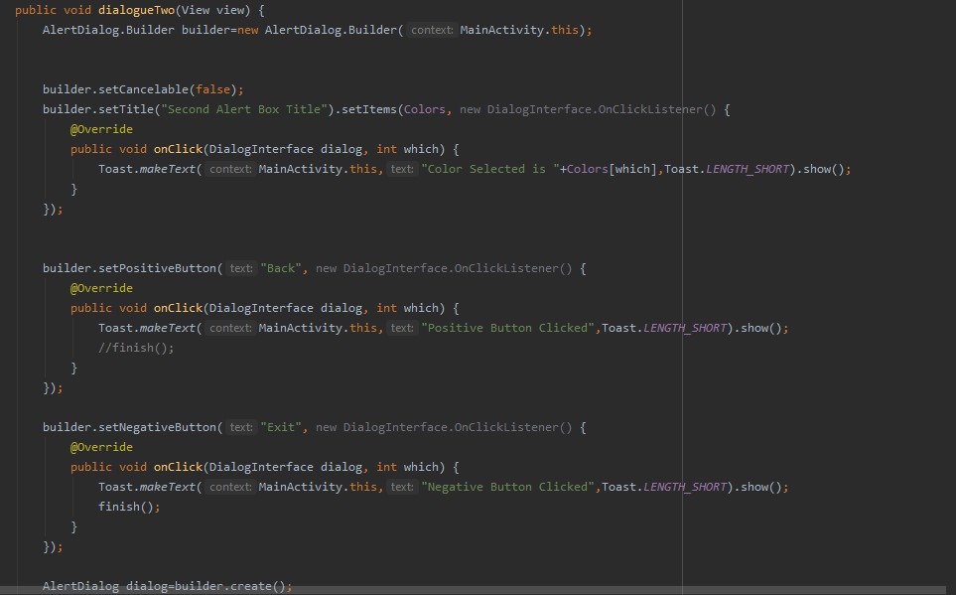

This will display a list of colors which is declared at the start.



The output will be as follows:

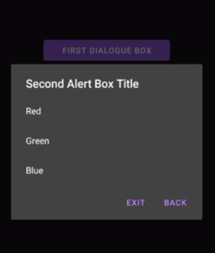

And if I click on one of the color item it will be displayed in the toast as well.

Now Come to the Third box the multi choice item list.

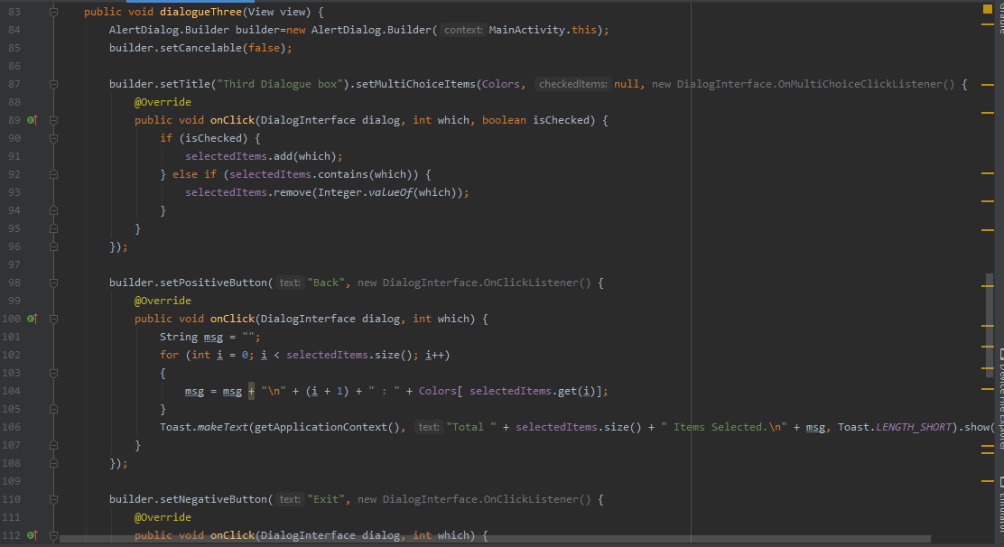

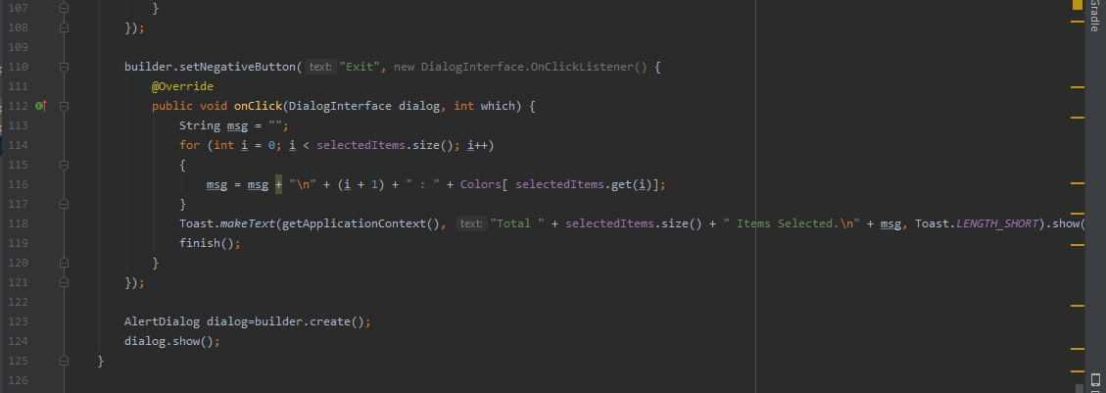

This will display the output like this:

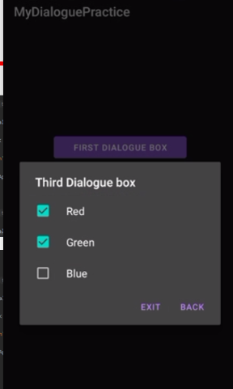

Here I can select multiple colors as well and on clicking they will be displayed on the toast as well.

Now comes our final Dialouge box. Fo which I have created a customized layout as well

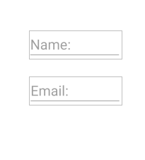

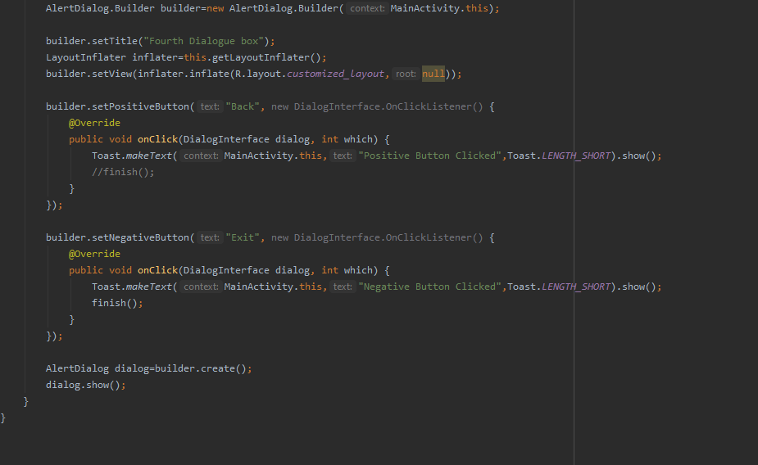

The Output will be ;

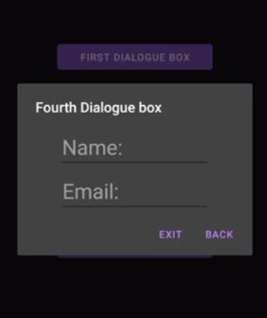

**Notifications**

For the notification purpose I am going to creat an android app in which there is going to be a button.  
I will set an onclick listner of the button to show the notification.   
So First after creating an app lets creat a sample button

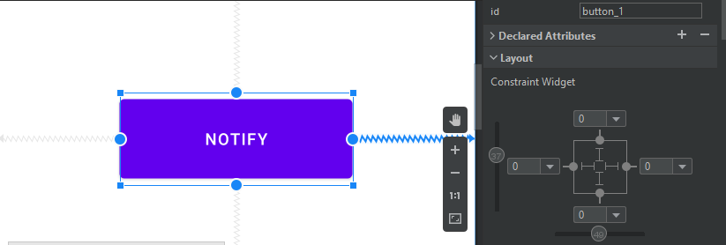

Now after creating this button we will hook it in the java file.

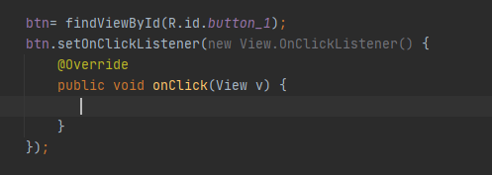

Now I am going to add the functionality of the Notifications function to the button

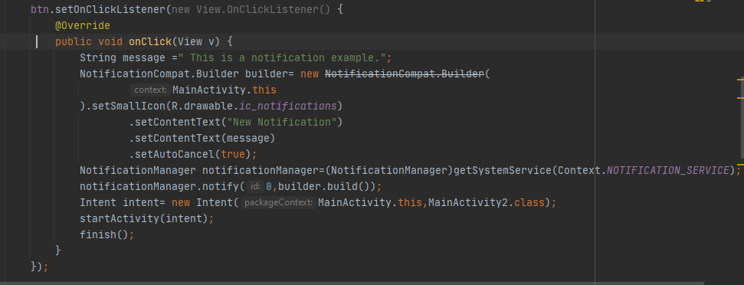

This code will set the title of the notification as the “New notification” and set an icon for the notificatiion and then set the message from the message variable and the notify the object. Also it will intent a new Activity as well.

**Fragements**

Now we will do the part of fragements which are basically a type of activity navigation just like we see in many different apps like whatsapp etc. Because they sare simmilar to the activites but are light weight as compared to activities and you can add multiple fragments in a single activity.

So I am going to create an android project.

Now to add the functionality of the fragements I am going to add the blank fragments 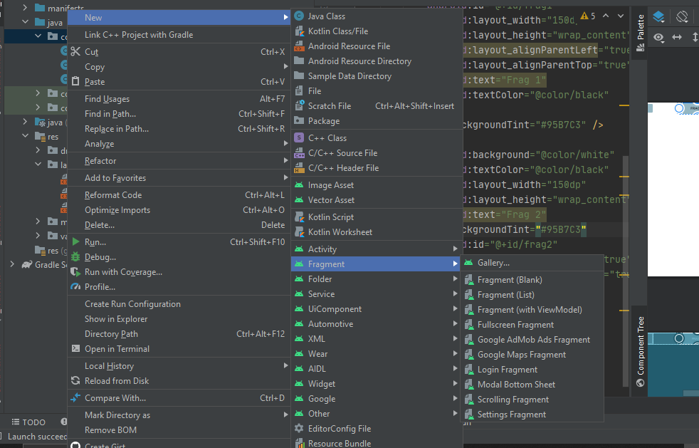

Here I amadding 2 fragments here one as Frag 1 and the other as Frag 2. So that we can show the manipulation of the fragements.

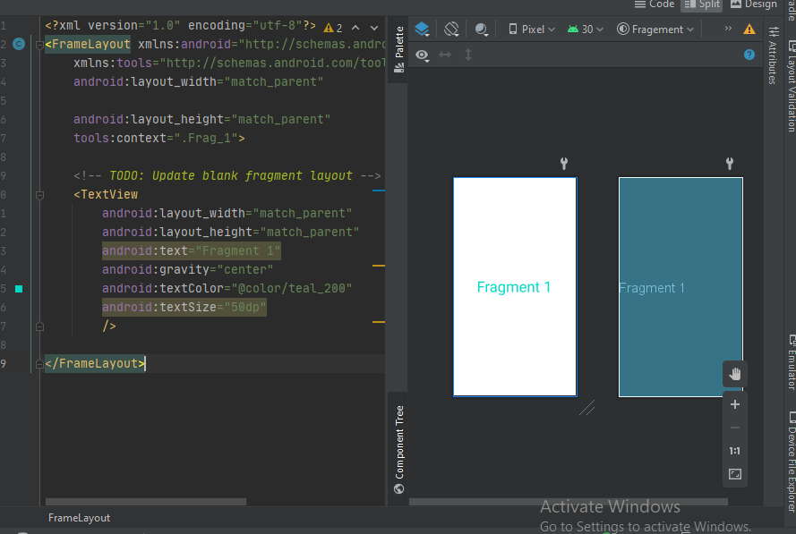

That was fragement 1

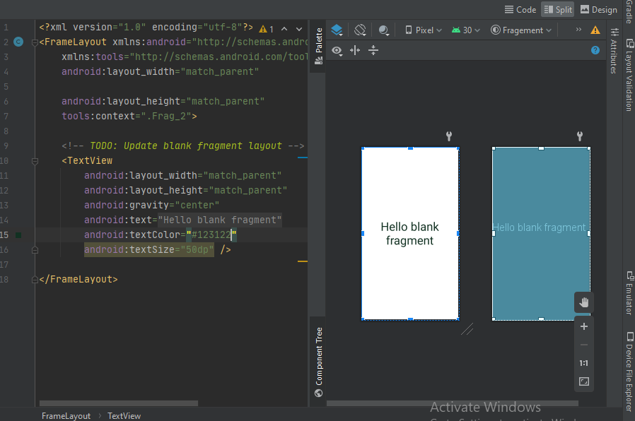

That is fragment 2

Now we will code for the manipulation of the rendering of the fragements

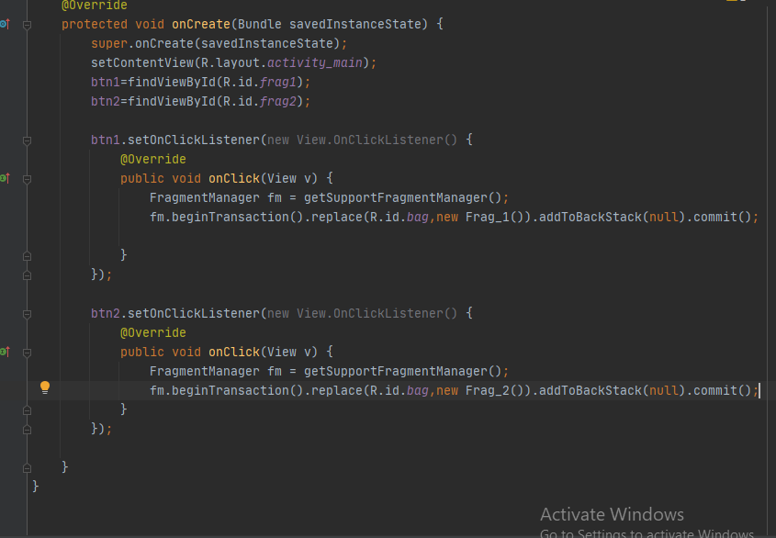

This is the code for the rendering of the fragment

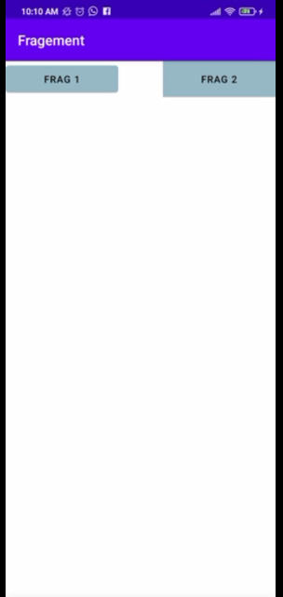

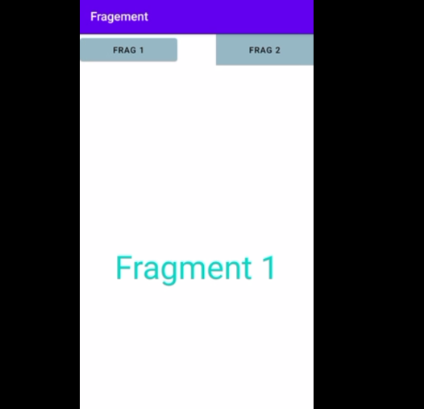

By clicking on the frag 1

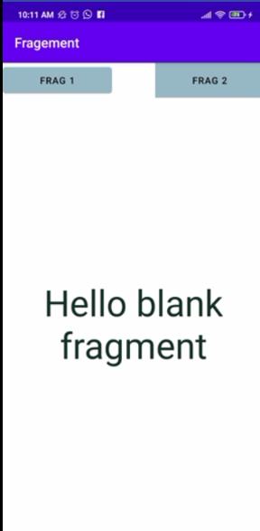

By clicking on the frag 2